* **Timer.js //To enable/disable timer clock**

#pragma strict

private var timeTF : GUIText;

public var alertReference : GameObject;

private var scoreSF: GUIText;

public var youWT : GameObject;

public var totalS: GUIText;

private var rdl : redolevel;

function Start () {

Screen.sleepTimeout = SleepTimeout.NeverSleep;

Screen.orientation=ScreenOrientation.LandscapeLeft;

Camera.main.GetComponent(AudioSource).Play();

rdl=Camera.main.GetComponent(redolevel);

rdl.enabled=false;

totalS.enabled=false;

timeTF = gameObject.guiText;

scoreSF=GameObject.Find("score_text").guiText;

Time.timeScale=1;

InvokeRepeating("ReduceTime",1,1);

}

function Update () {

if (Input.GetKeyDown(KeyCode.Escape))

Application.Quit();

}

function ReduceTime() {

if(timeTF.text=="1")

{

Time.timeScale=0;

if(int.Parse(scoreSF.text)>=20)

{

Instantiate(youWT,new Vector3(0.5f,0.5f,0),transform.rotation);

totalS.text=(int.Parse(scoreSF.text)*10).ToString();

totalS.enabled=true;

Camera.main.GetComponent(AudioSource).Stop();

}

else{

Instantiate(alertReference,new Vector3(0.5f,0.5f,0),transform.rotation);

rdl.enabled=true;

Camera.main.GetComponent(AudioSource).Stop();

}

}

timeTF.text=(int.Parse(timeTF.text)-1).ToString();

}

* **Pot.js //To destroy pots and bombs when user uses swipe**

#pragma strict

public var splashReference: GameObject;

private var randomPos: Vector3=new Vector3(Random.Range(-1,1),Random.Range(0.3f,0.7f),Random.Range(-6.5f,-7.5f));

private var scoreReference:GUIText;

function Start () {

scoreReference=GameObject.Find("score_text").guiText;

}

function Update () {

if(gameObject.transform.position.y<-36)

{

Destroy(gameObject);

}

}

function OnTriggerEnter(other:Collider)

{

if(other.gameObject.tag=="Line" && gameObject.tag=="pot")

{

audio.Play();

Destroy(gameObject);

Instantiate(splashReference,randomPos,Quaternion.identity);

scoreReference.text=(int.Parse(scoreReference.text)+1).ToString();

}

else if

(other.gameObject.tag=="Line" && gameObject.tag=="bomb")

{

audio.Play();

Destroy(gameObject);

scoreReference.text=(int.Parse(scoreReference.text)-1).ToString();

}

}

* **MtkiSpawn.js //To initiate pots and bombs at random range**

#pragma strict

private var throwForce:Vector3=new Vector3(0,15,0);

public var mtkiReference:GameObject[];

function Start () {

InvokeRepeating("SpawnMtki",Random.Range(0.1f,0.5f),Random.Range(1.0f,5.0f));

}

function Update () {

}

function SpawnMtki(){

var i:byte;

for(i=0;i<4;i++)

{

var mtki:GameObject=Instantiate(mtkiReference[Random.Range(0,4)],new Vector3(Random.Range(-10,10),Random.Range(-10,-5),5),Quaternion.Euler(270,90,0)) as GameObject;

mtki.rigidbody.AddForce(throwForce,ForceMode.Impulse);

}

}

* **LineHandler.js //To draw line when user uses swipe**

#pragma strict

public var c1 : Color = Color.yellow;

public var c2 : Color = Color.red;

private var lineGo : GameObject;

private var lineRenderer : LineRenderer;

private var i : int = 0;

function Start () {

lineGo = new GameObject("Line");

lineGo.tag = "Line";

lineGo.AddComponent(LineRenderer);

lineRenderer=lineGo.GetComponent(LineRenderer);

lineRenderer.material=new Material(Shader.Find("Mobile/Particles/Additive"));

lineRenderer.SetColors(c1, c2);

lineRenderer.SetWidth(0.3f, 0);

lineRenderer.SetVertexCount(0);

}

function Update () {

if(Input.touchCount > 0)

{

var touch : Touch = Input.GetTouch(0);

if(touch.phase == TouchPhase.Moved)

{

lineRenderer.SetVertexCount(i+1);

var mPosition : Vector3 = new Vector3(Input.mousePosition.x, Input.mousePosition.y, 15);

lineRenderer.SetPosition(i, Camera.main.ScreenToWorldPoint(mPosition));

i++;

var bc : BoxCollider = lineGo.AddComponent(BoxCollider);

bc.transform.position = lineRenderer.transform.position;

bc.size = new Vector3(0.1f, 0.1f, 0.1f);

bc.isTrigger=true;

}

if(touch.phase == TouchPhase.Ended)

{

lineRenderer.SetVertexCount(0);

i = 0;

var lineColliders : BoxCollider[] = lineGo.GetComponents(BoxCollider);

for(var b : BoxCollider in lineColliders)

{

Destroy(b);

}

}

}

}

* **Splash.js //To initiate splash/explosion effect when user swipes pots/bomb**

#pragma strict

private var randomAlpha: Color;

private var currentAlpha: float;

function Start () {

randomAlpha=new Color(1,1,1,Random.Range(0.3f,0.5f));

gameObject.renderer.material.color=randomAlpha;

InvokeRepeating("ReduceAlpha",0.3f,0.3f);

}

function Update () {

}

function ReduceAlpha(){

currentAlpha=gameObject.renderer.material.color.a;

if(gameObject.renderer.material.color.a<=0.1f)

{

Destroy(gameObject);

}

else{

gameObject.renderer.material.color=new Color(1,1,1,currentAlpha-0.1f);

}

}

* **Redolevel.js //To relode level again**

#pragma strict

function OnGUI()

{

if(GUI.Button(Rect((Screen.width/2)-60,100,120,50),"Try Again"))

{

Application.LoadLevel(Application.loadedLevel);

}

}

**//The level start screen**

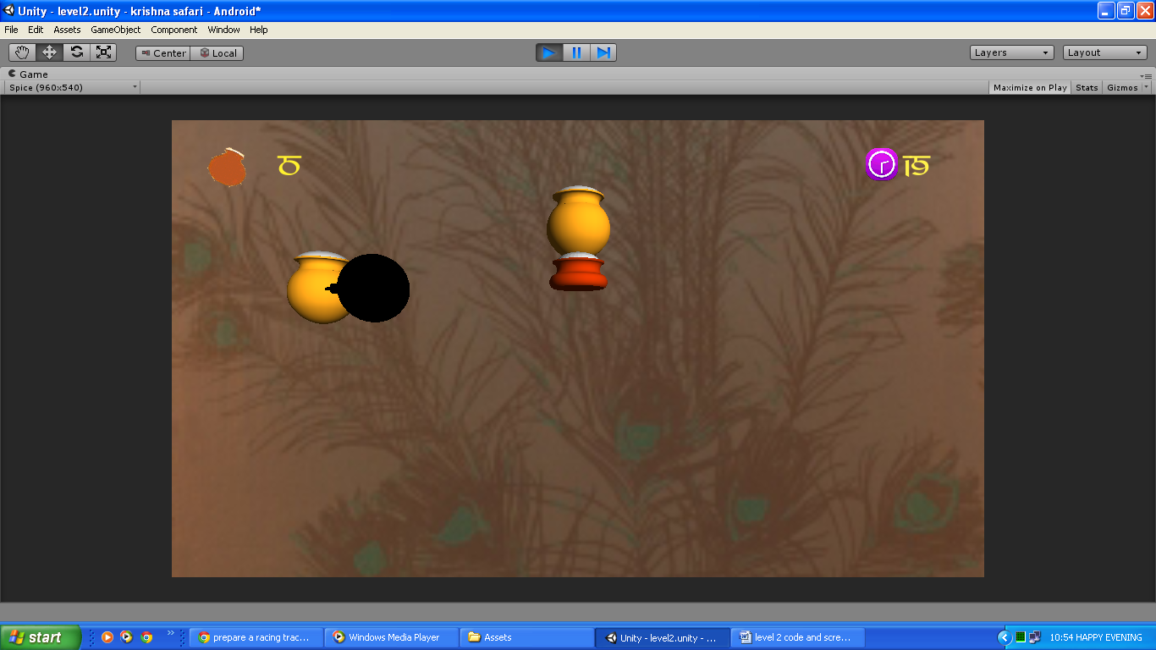

**//The game over screen**

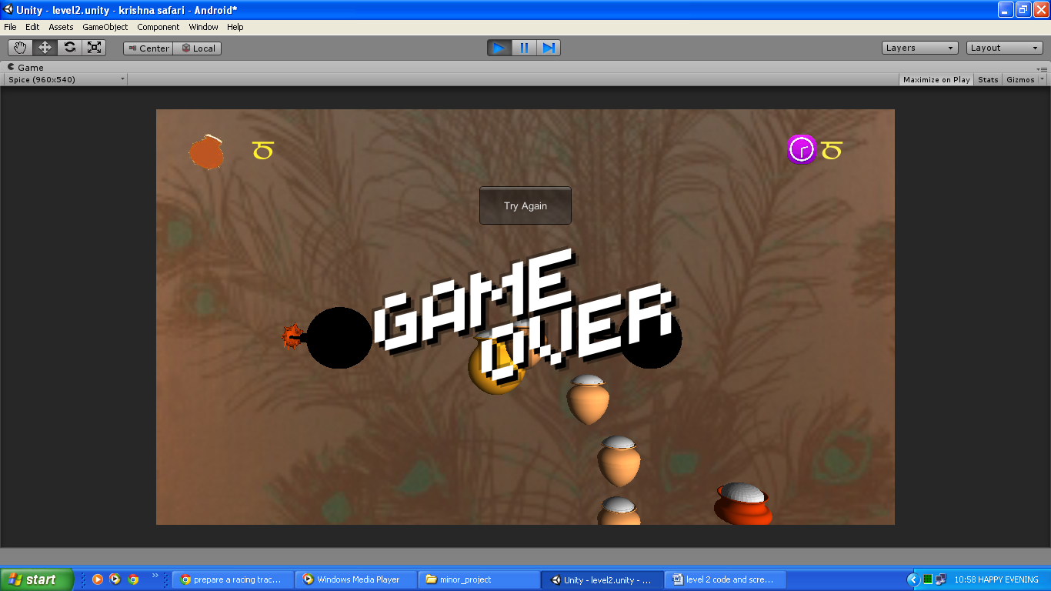

**//The You Win screen**

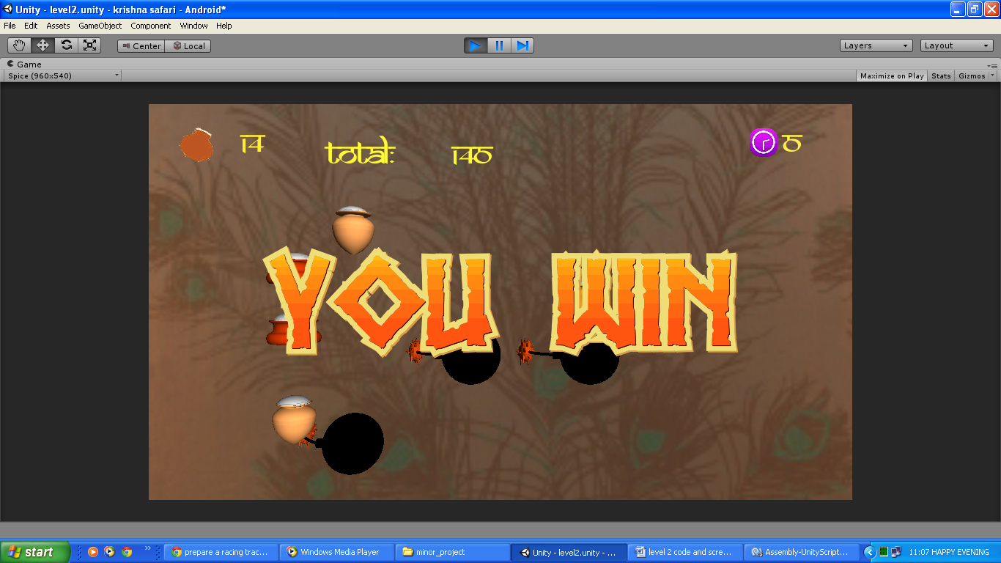

**//When User swipes to cut pots and bombs**

**(plz ye apne phone se screen shot clik kr k lga lio)**